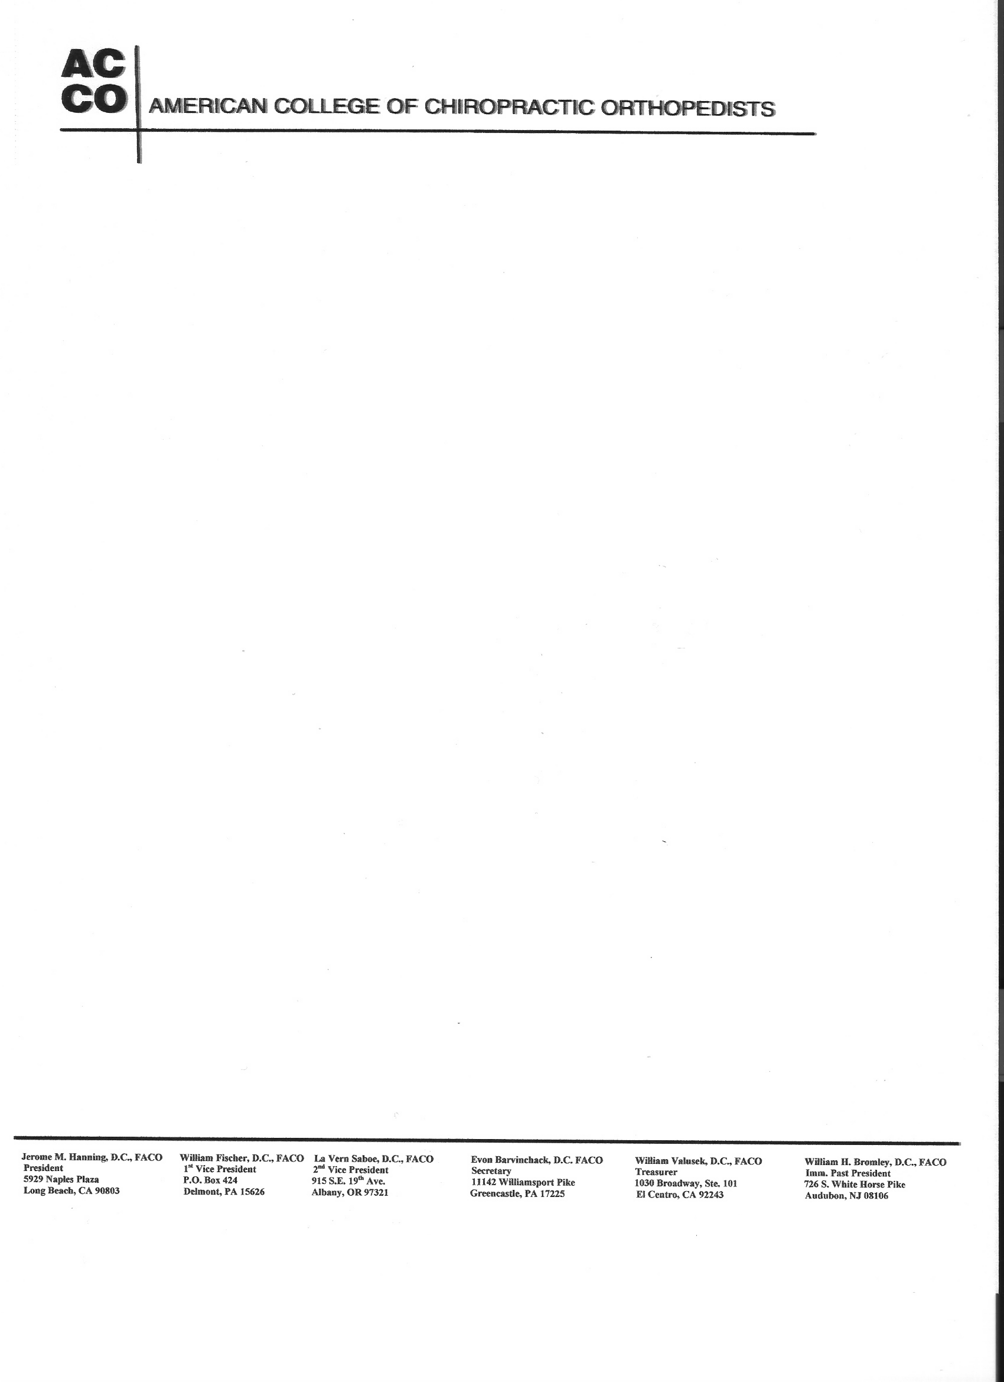
July 25, 2007

Dear Fellow ACCO Members:

The ACCO is very pleased and proud to honor Dr. Lipe, who has contributed so much to the concept and development of the orthopedic specialty within our profession.

The F. Maynard Lipe Scholarship is available to those doctors enrolled in Post Graduate Orthopedics leading to diplomat status or the masters program in musculoskeletal manipulation and rehabilitation. This is good news for the advanced postgraduate student and I look forward to receiving articles for consideration of this award, which is a minimum of $500.00 annually. The candidate will submit, by December 31st annually, an original work–up of an interesting orthopedic patient suitable for publishing in the Journal of the American College of Chiropractic Orthopedists (JACCO). The winner or winners will be granted free registration to the annual ACCO convention where the award will be formally presented.

The ACCO executive board would like to increase the amount of the award thereby stimulating a greater interest in participation. Since the award is governed by the interest earned in the fund it will be necessary to increase the Lipe fund.

We therefore, NEED YOUR HELP, and are asking you to give generously to help the Lipe Scholarship Fund grow. As the ACCO is a nonprofit organization, your donations should be fully tax deductible. Be sure to consult with your financial advisor for your specific tax needs and circumstances.

Most Sincerely Yours,

Jesse R. Rothenberger, DC, FACO, FICC
Chairman - Lipe Scholarship

I, Dr. ________________________________ donate the following for the ACCO F. Maynard Lipe Scholarship Fund:

$25.00_____ $50.00_____ $75.00_____ $100.00_____ $500.00_____ OTHER______

Please forward your donation to ACCO Treasurer,
Dr. David Swensen
40 West Foster Street
Melrose, MA, 02176

